Exercises grade 4
Unit 12 – lesson 1
- Circle the correct word.

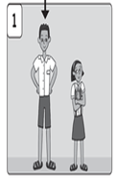
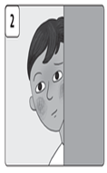

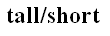
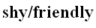

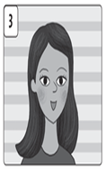
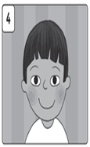

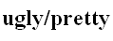
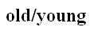

II. Write sentences using the past simple of be.
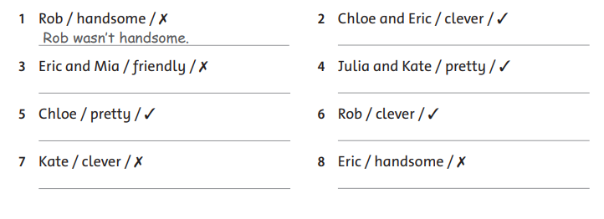

Answer key
I. Circle the correct word.
1) tall 2) shy 3) pretty 4) young

II. Write sentences using the past simple of be.
2) Chloe and Eric were clever.
3) Eric and Mia weren’t friendly.
4) Julia and Kate were pretty.
5) Chloe was pretty.
6) Rob was clever.
7) Kate wasn’t clever.
8) Eric wasn’t handsome.

